

**Higher National Unit Specification: General Information**

**Statement and Confirmation of Own Work**

**Unit Title: Computer System Fundamentals**

**Unit code: H173 34**

**Superclass: CB**

**Publication Date: January 2019**

**Source: Scottish Qualifications Authority**

**Version: 01**

**Student declaration**

I have read and understood SQA HND’s Policy on Academic Dishonesty and Plagiarism.

I can confirm the following details:

**Student ID/Registration number : 187706750**

**Name : Suan Thiha Nyan**

**Centre Name : KMD Computer Centre (Yangon)**

**Assessor’s Name : Kay Thwe Win**

**Student Signature : Suan**

**Submitted Date : 28-February-2019**

Contents

**Task 1** 6

**Window 7 installation** 6

**Begin our computer with the discs** 6

**Step 2** 6

**Choose the setup option of the window version** 6

**Step 3** 7

**Starting the installation process of the window 7** 7

Step 4 7

Reading the license terms of the software 7

**Step 3** 8

**Creating a new partition for the installation of the window 7 version** 8

**Step 4** 9

**Installing the windows 7 versions to the regarded partition hard drive and installation process** 9

**Step 5** 10

**Insert the username and facts about pc (or) computer** 10

**Step 6** 10

**Enter the product key and choose the window settings of the Microsoft window version** 10

**Step 7** 11

**Set up the time zone** 11

**Step 8** 11

**Window installation finished!!!** 11

References 11

**Task 2** 12

**Installation of the configure application** 12

**Step 1** 12

**Step 2** 12

Choose the path for the download for this application 12

**Step 3** 13

**Open the installer** 13

13

**Step 4** 13

**Run the setup** 13

**Step 5** 14

**Agree for the official software agreement** 14

**Step 6** 14

**Select your constituents as you like** 14

14

**Step 7** 15

**Indicate the pathof installation** 15

**Step 8** 15

**Installation completed!** 15

**Step 9** 16

**Initiating and finishing the setup** 16

**Step 10** 16

**Usual file links** 16

**Step 11** 17

**Start Using the Code::Blocks Software** 17

References 17

References 18

**Task 3** 18

**Antivirus software installation** 18

**Step 1** 18

**Download the microsoft security essentials** 18

**Step 2** 19

**Run the setup** 19

**Step 3** 19

**Read the license agreement** 19

**Step 4** 20

**Joining the customer experience program** 20

**Step 5** 20

**Optimize security for the pc** 20

**Step 6** 21

**Starting the installation of the Microsoft security essential** 21

**Step 7** 21

**Finishing the installation** 21

References 22

# **Task 1**

# **Window 7 installation**

## **Begin our computer with the discs**

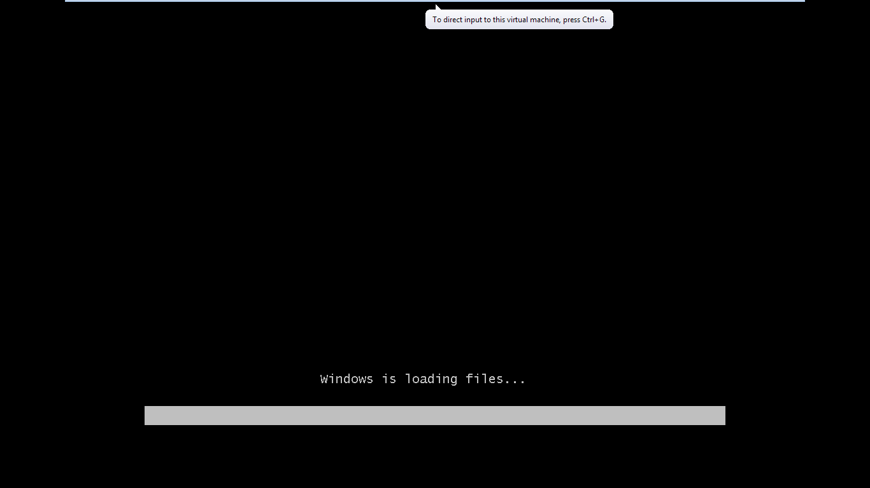

First of all, we need to place the dicsc including The installer of the window 7 version. When we finished to place the discs into our computer, we must start the computer. When the computer is start working, press any key to boot from the discs. When it was finished, the window setup will begin.

# **Step 2**

# **Choose the setup option of the window version**

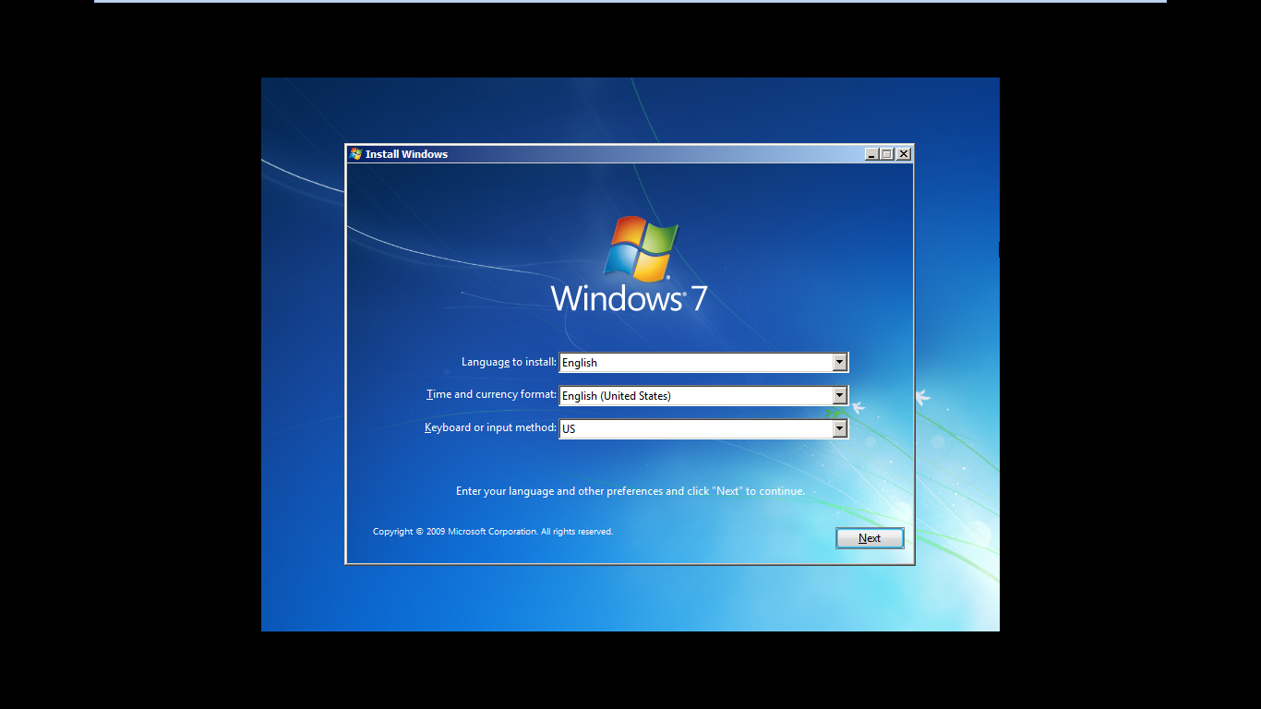

When the setup of the window 7 version loads, a window will present in front of our monitor screen. Then, select the language, the type of keyboard, the format of current time. If we finish, click ‘Next” Button to continue.

# **Step 3**

# **Starting the installation process of the window 7**

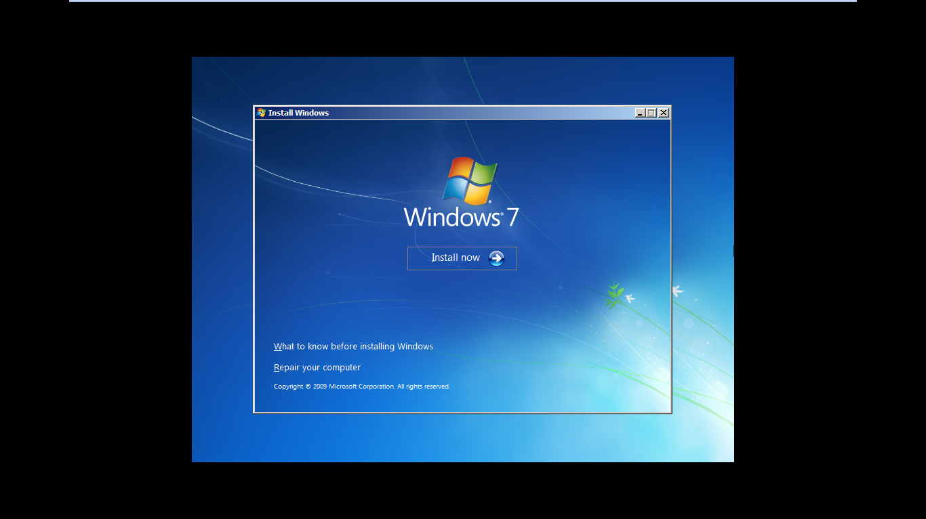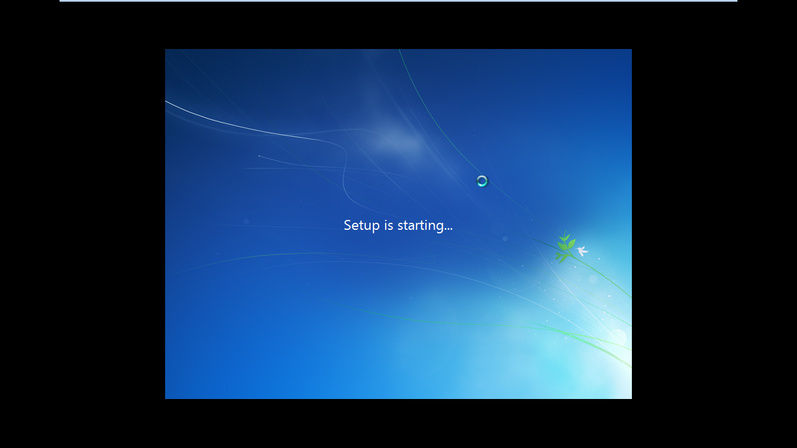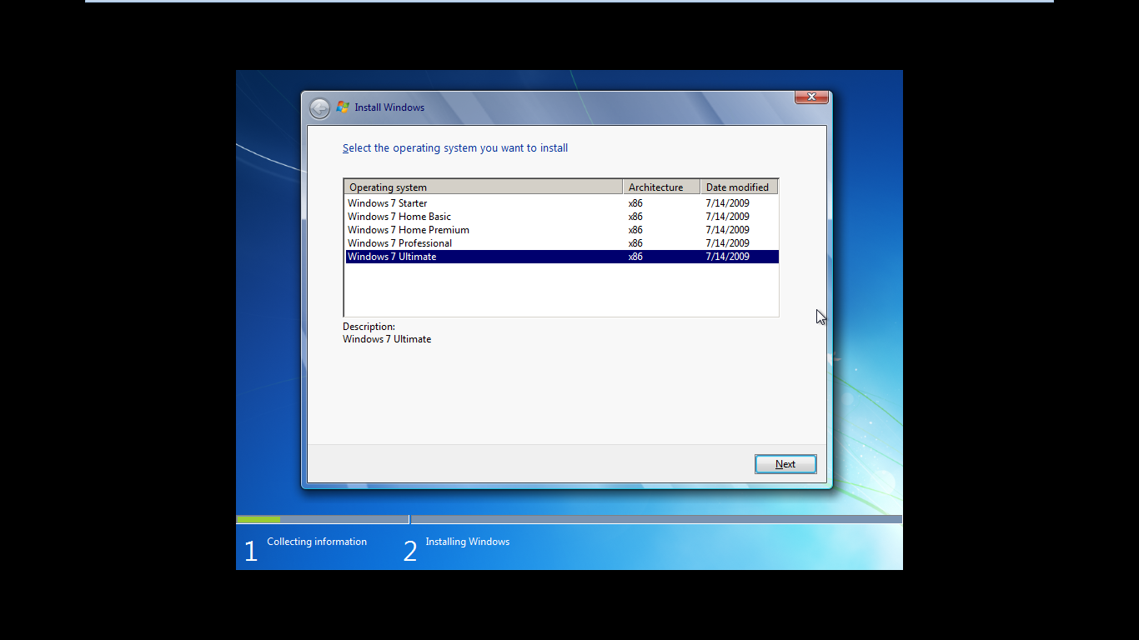

When we finished the step 2, the window will appear and it said us to install the window 7 version. So, we click ‘Install Now’ Button and let the installation begin. When the setup is finished, it will show a lot of options of the window 7 versions.But now, we need to choose window 7 ultimate version and then click next button.

# Step 4

# Reading the license terms of the software

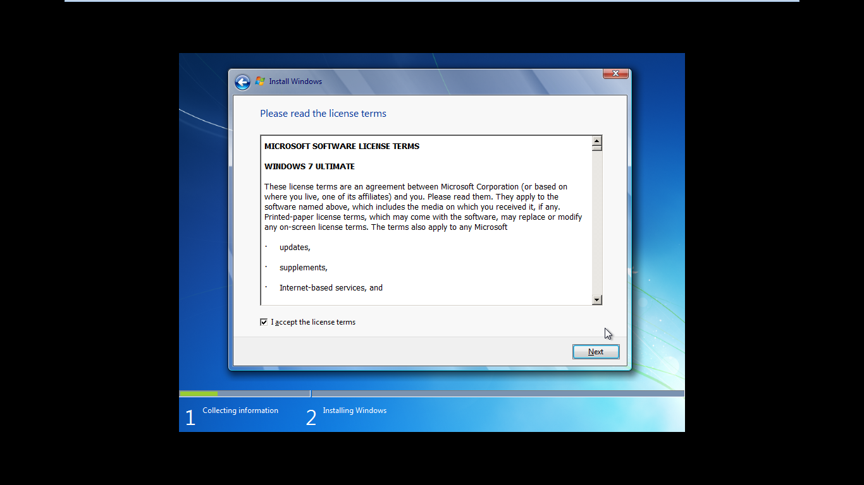

For this step we need to read the license agreement of the window 7 installation.

# **Step 3**

# **Creating a new partition for the installation of the window 7 version**

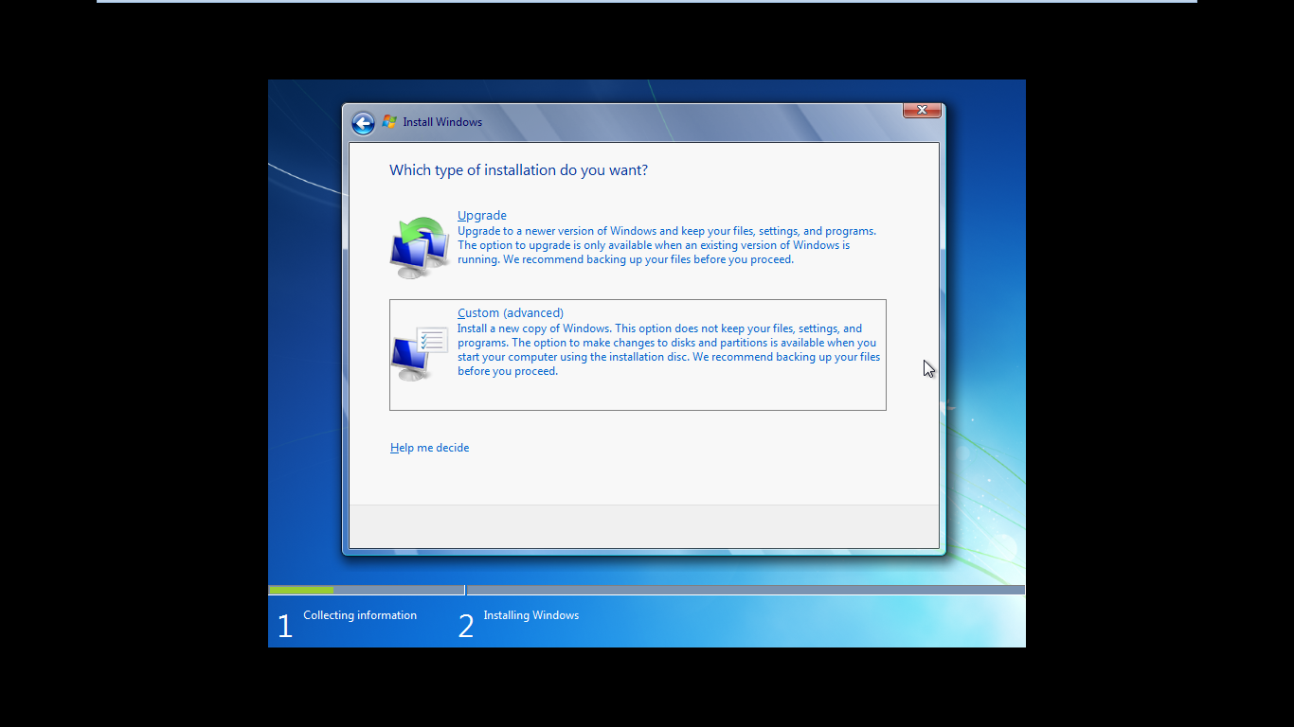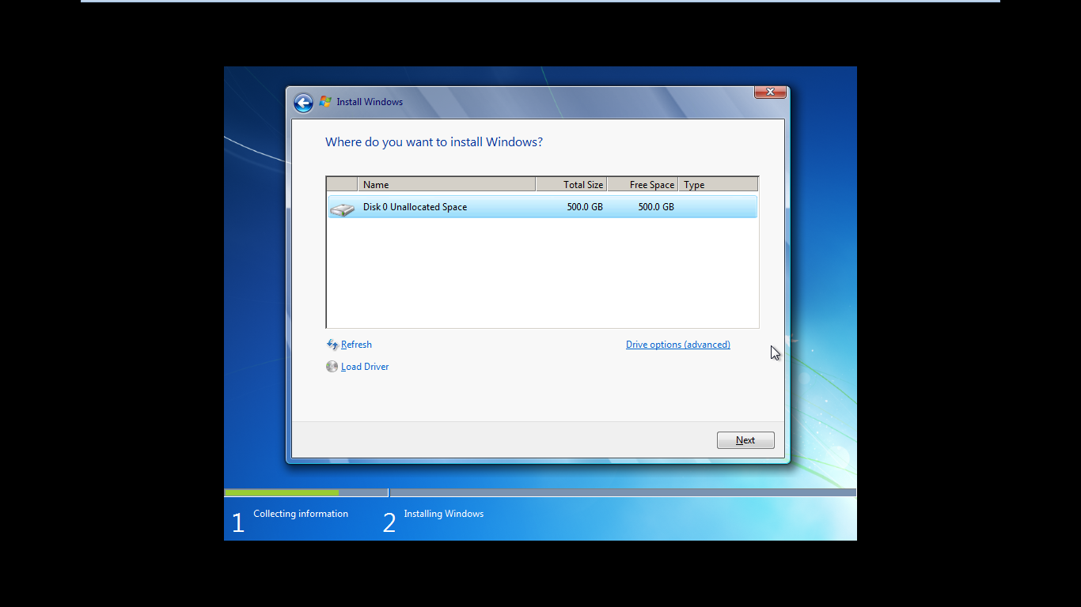

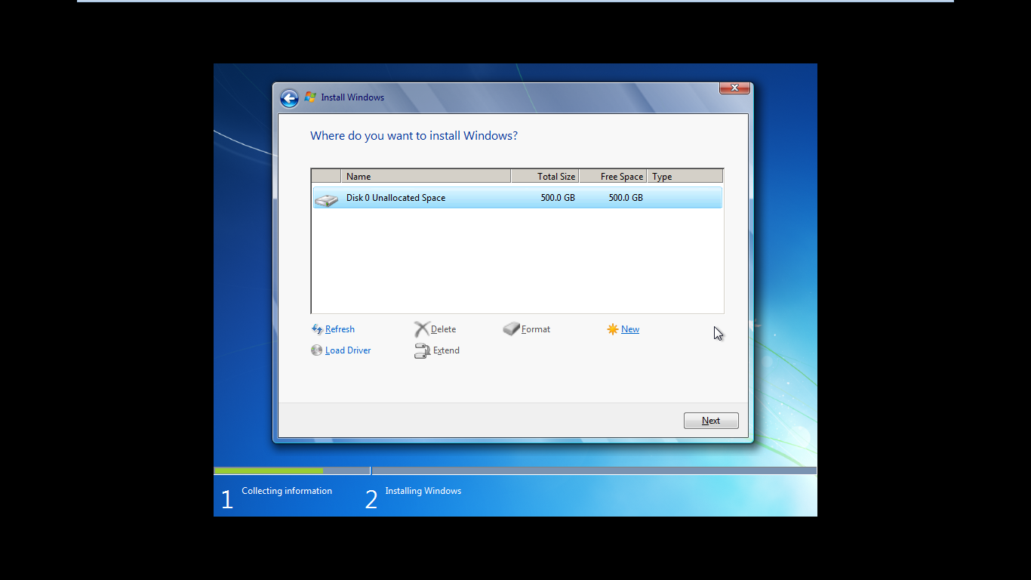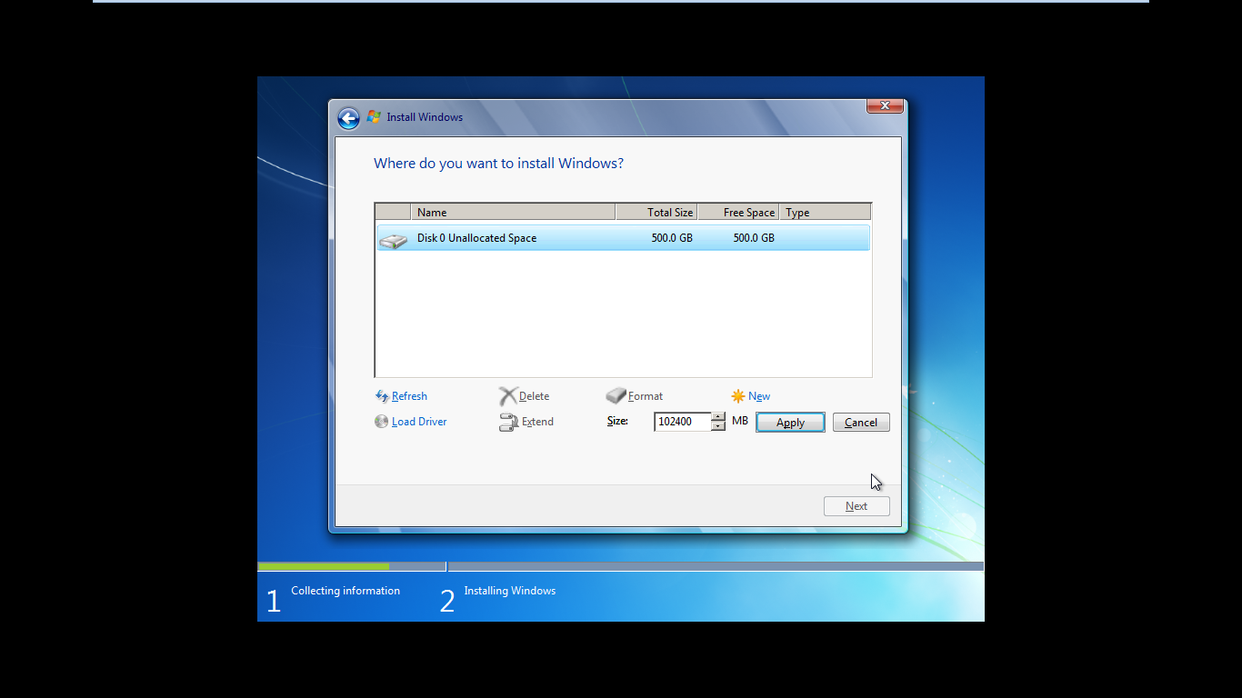

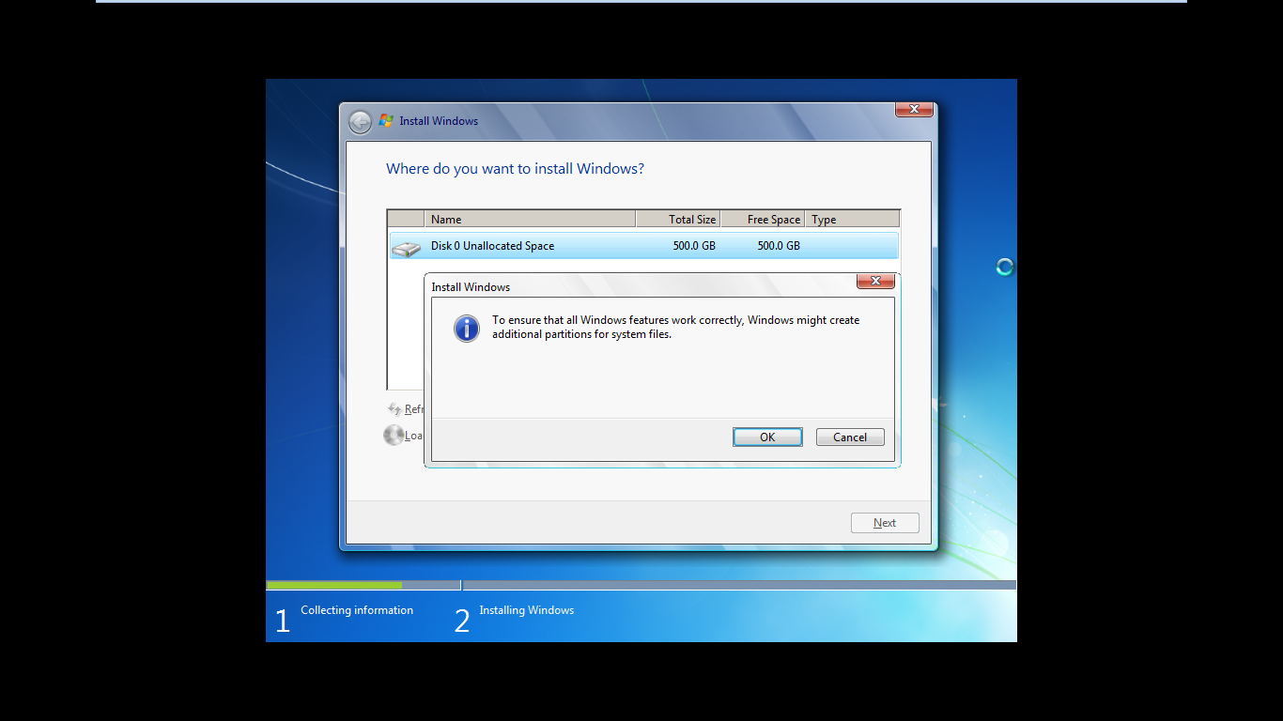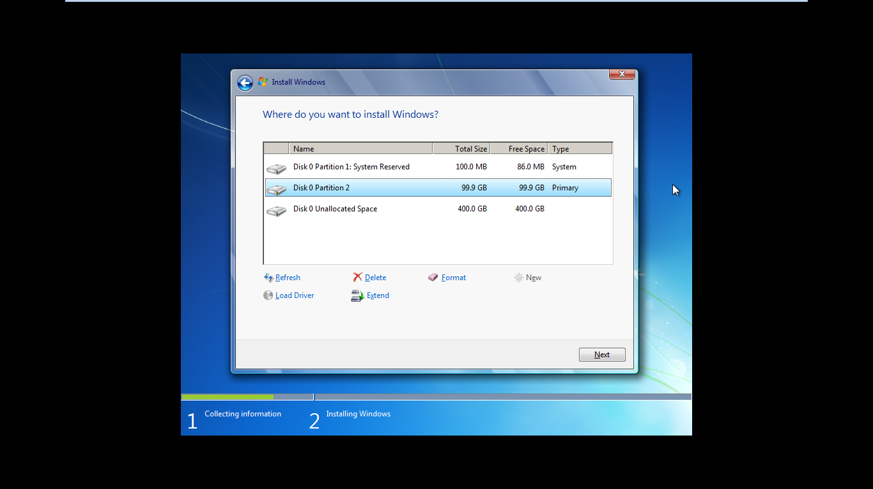

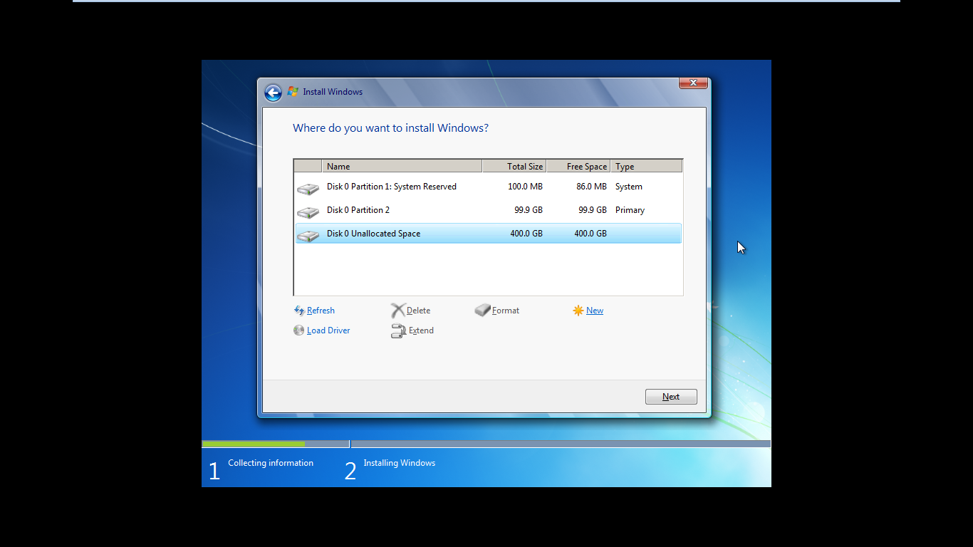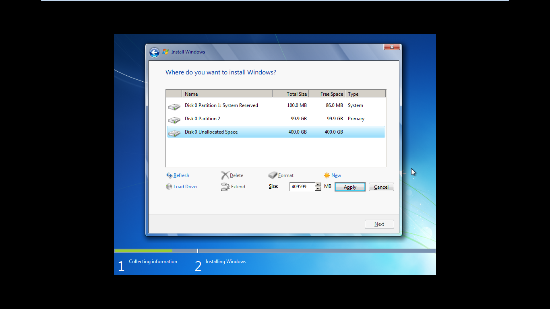

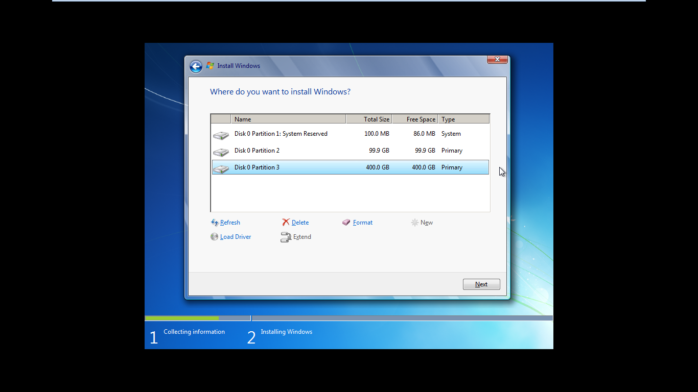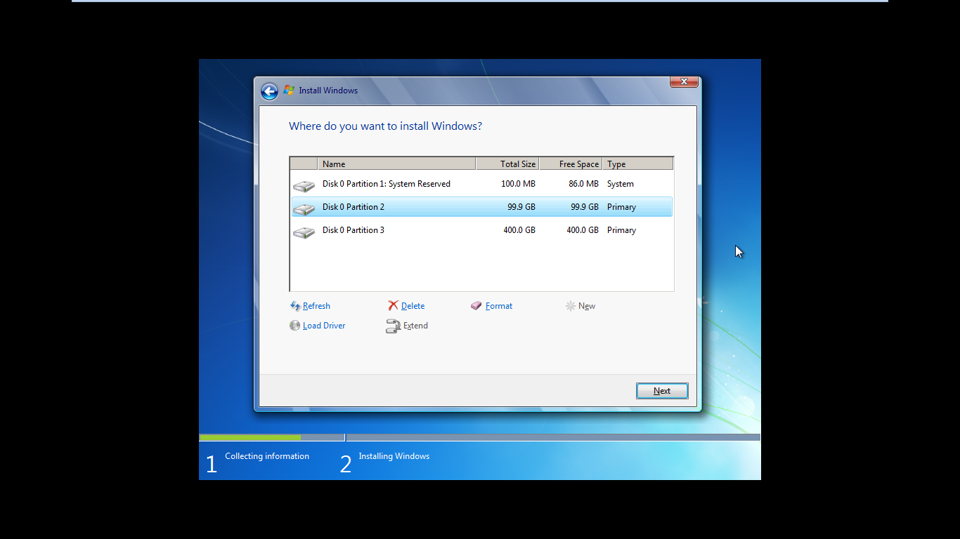

For this step, we have two options for the data on the pc. They are hard drive and new partition. If the data of the pc are in the hard drive, we need to delete the data off of hard drive. Then format it. Later, we need the select the hard drive from the hard drives’ list. Then we need to click drive options and after we done that, click format option from drive options. But if we do not have any partition, we need to built a new partition first. And like a first option, select the hard drive from the hard drives’ list. Then we need to click drive option and select the new from drive options. And we need to choose the size and the click OK Button.

# **Step 4**

# **Installing the windows 7 versions to the regarded partition hard drive and installation process**

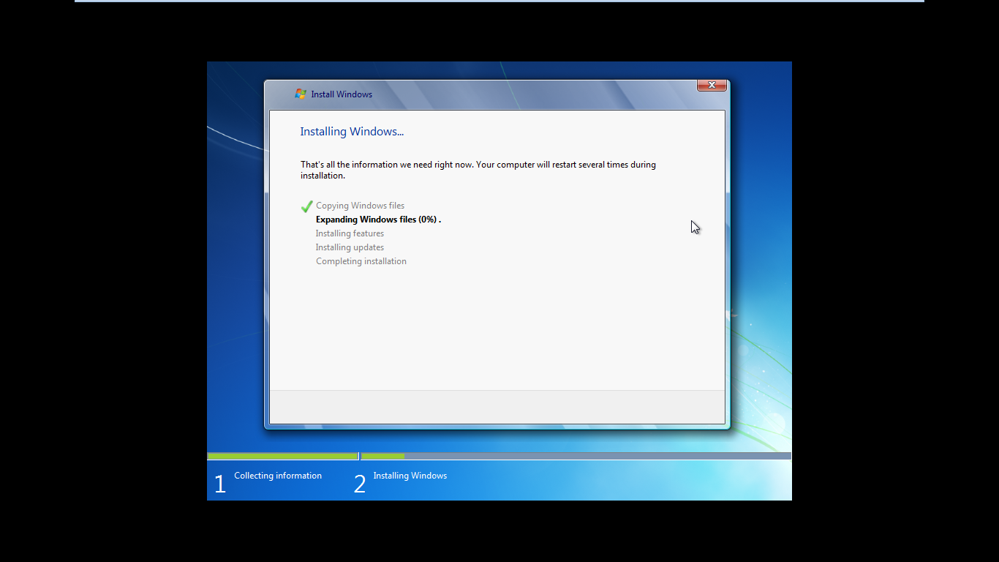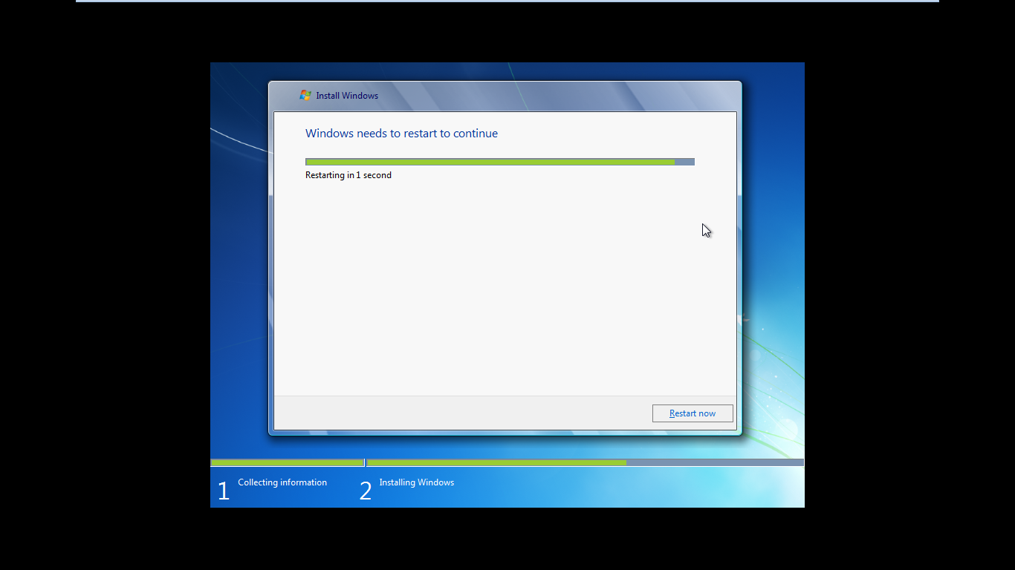

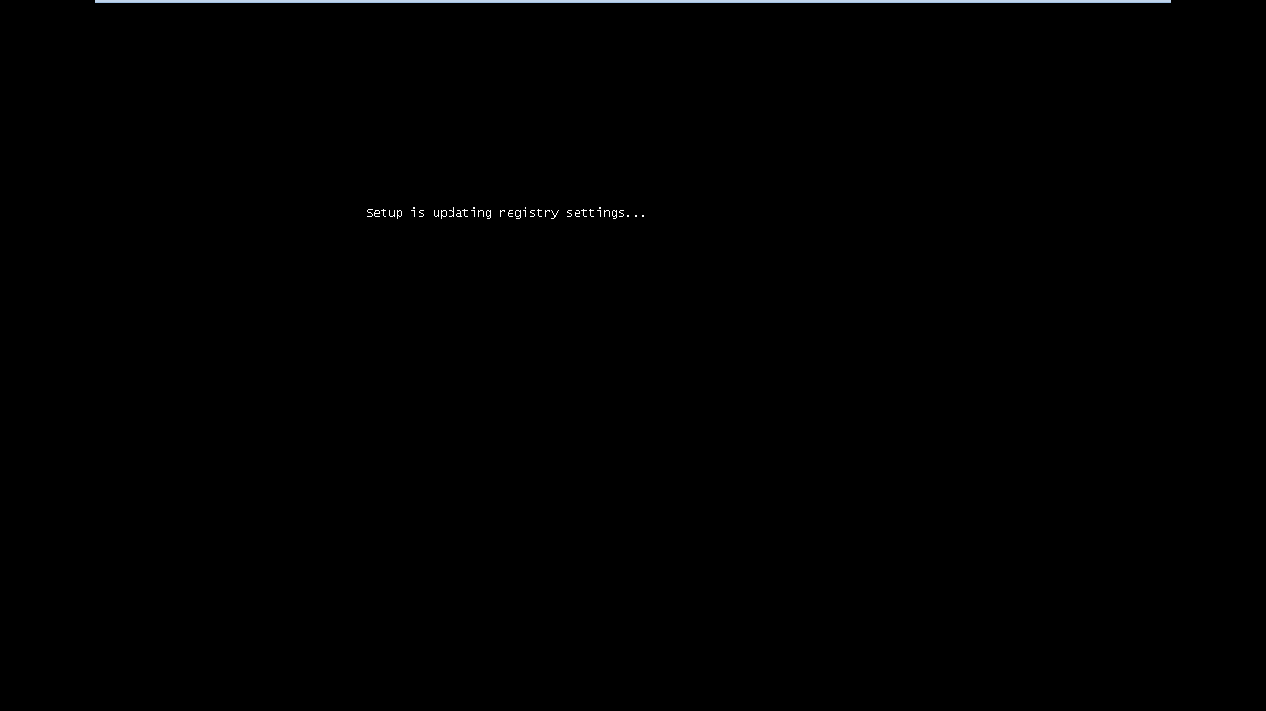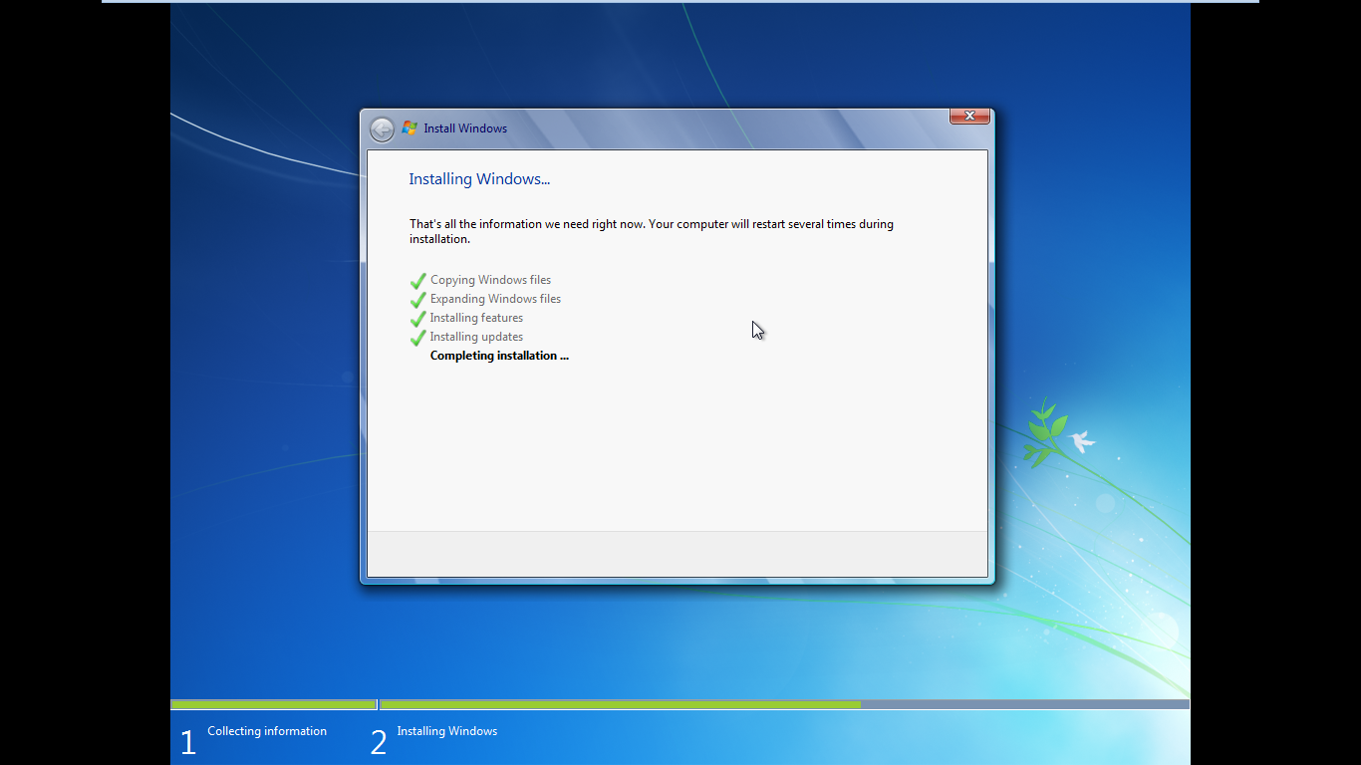

When we finished to make a new partition for the window 7, we can start the installation process of the Microsoft window 7 version. And the installation will make itself procedurely.

# **Step 5**

# **Insert the username and facts about pc (or) computer**

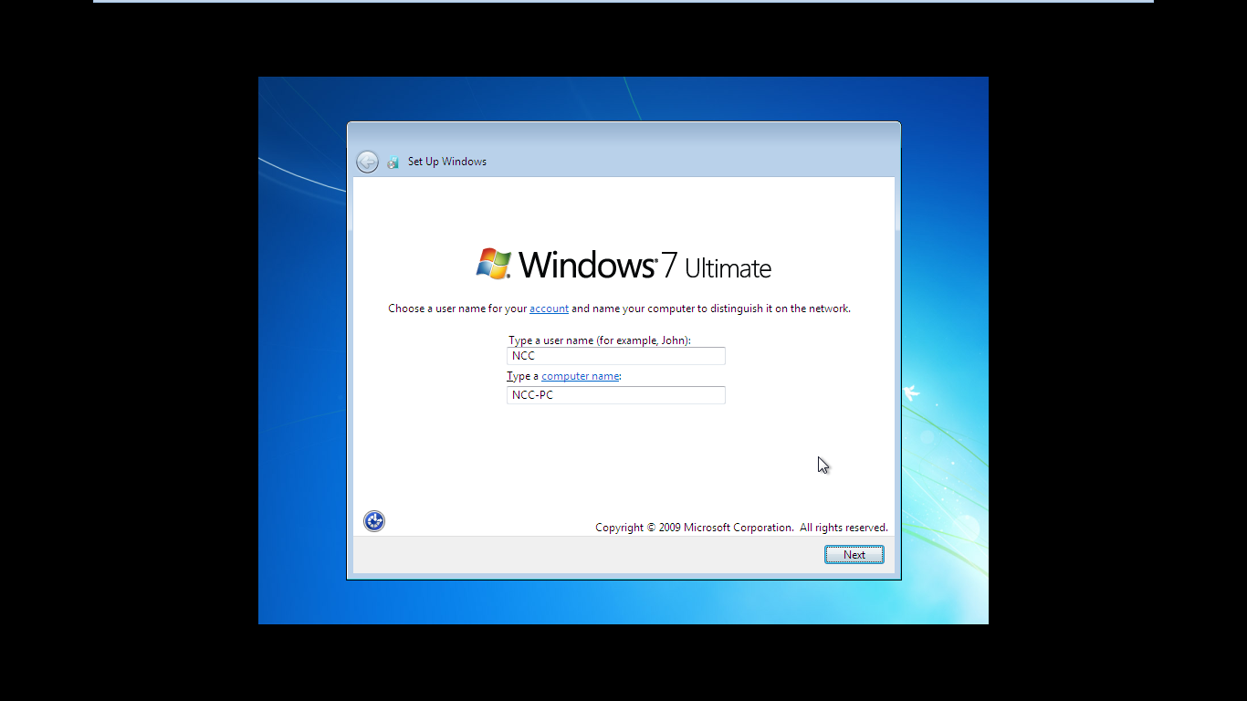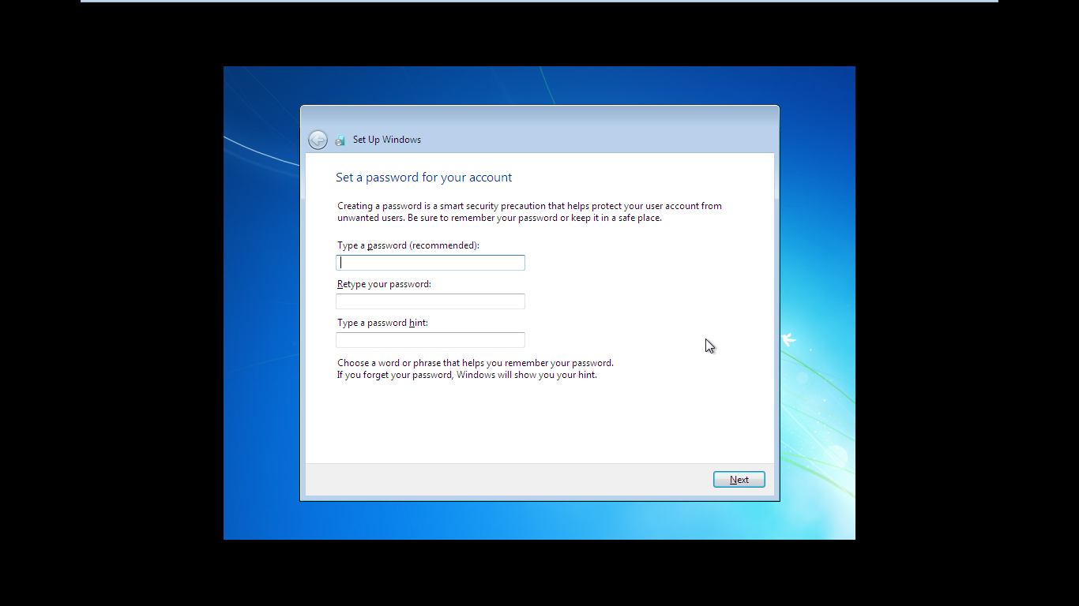

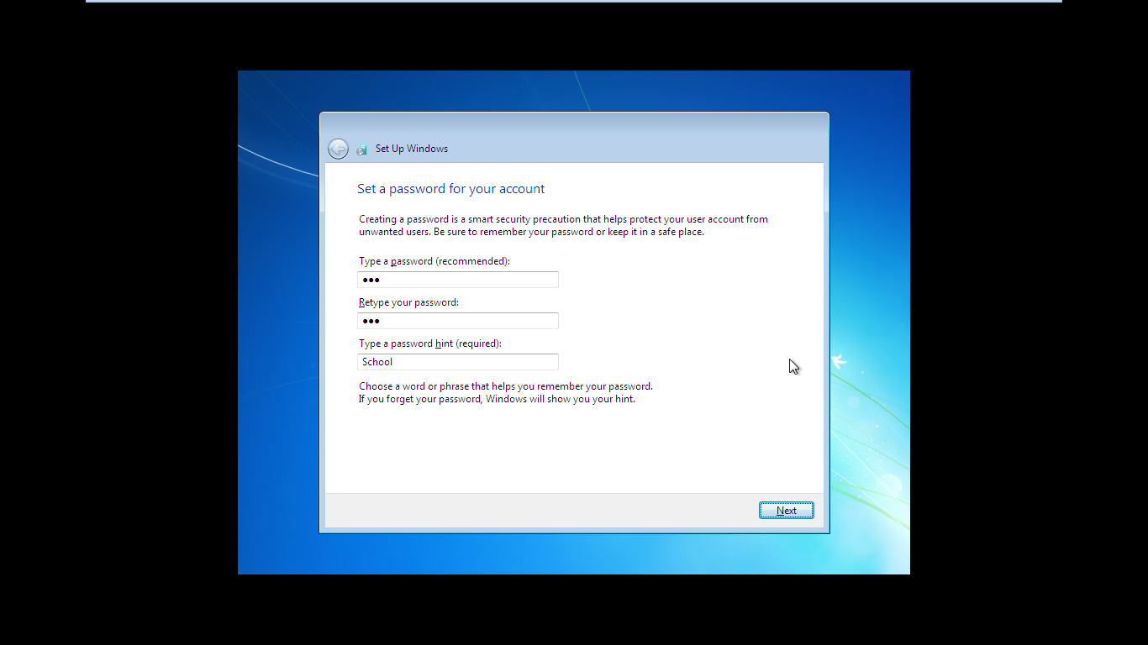

When we finished step 5, we need to insert the username and the name of the pc or computer into the setup window. Then, we need to input the password of the microsft account. When we finished the first step, we need to retype the password again to the textbox under the first one.

# **Step 6**

# **Enter the product key and choose the window settings of the Microsoft window version**

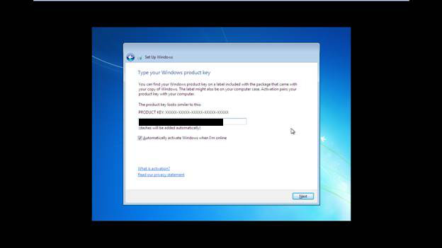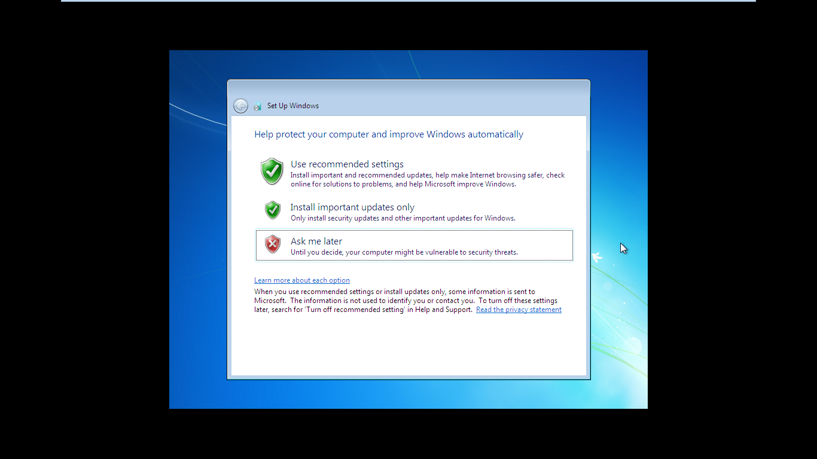

The process of the installation is almost finished.As next step, we must input the product key of the Microsoft window 7 version. The product key would include when we purchased for this discs. When we finished to input the product key, click next to continue. When we finished it, we need to choose the windowe settings. If we do not want to choose it yet, click ‘Ask me later’ button.

# **Step 7**

# **Set up the time zone**

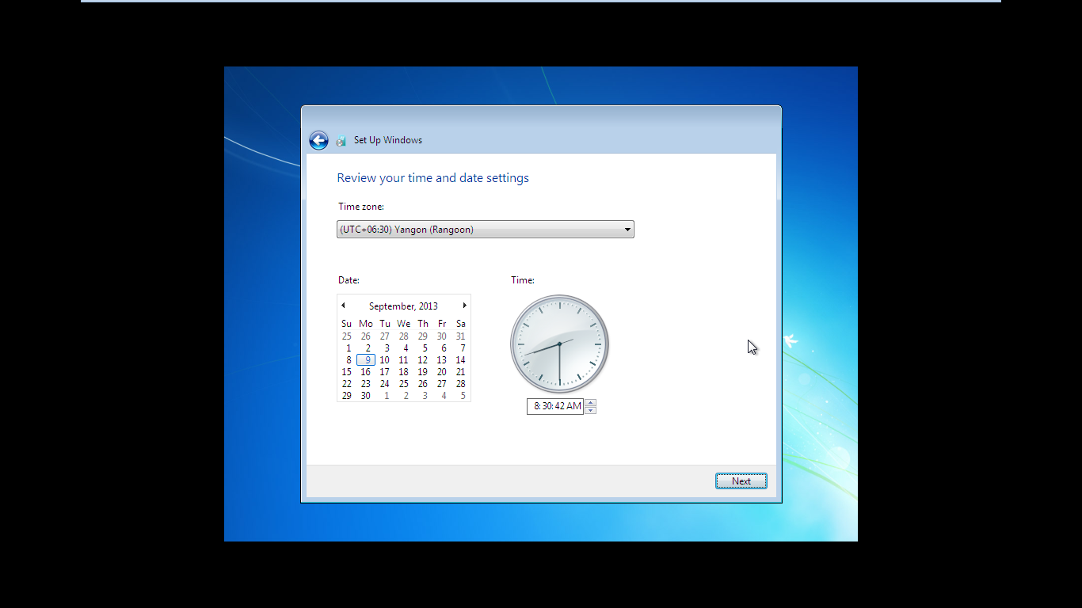

As a final step, we need to regard the time zone according to our country. Choose date and time correctly.

# **Step 8**

# **Window installation finished!!!**

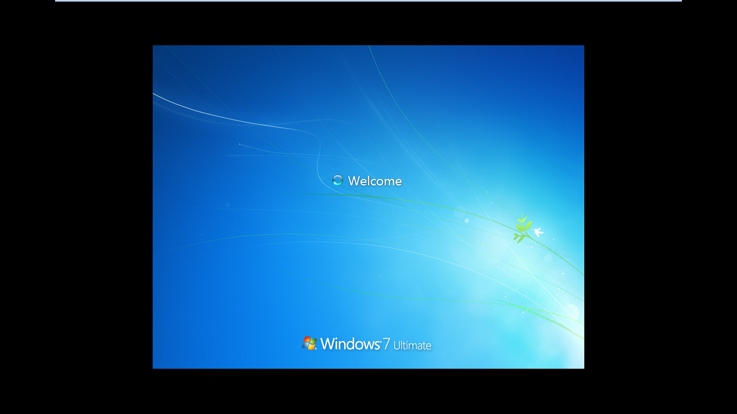

Now, the installation process of the window 7 version is completed. Now, we can enjoy this version.

# References

Robert Cowart and Brian Knittel, unknown. *www.computerworld.com.* [Online]   
Available at: https://www.computerworld.com/article/2528416/microsoft-windows-windows-7-installation-how-to-step-by-step.html  
[Accessed 27 February 2019].

wikihow.com, unknown. *www.wikihow.com.* [Online]   
Available at: https://www.wikihow.com/Install-Windows-7-(Beginners)  
[Accessed 27 February 2019].

# **Task 2**

## **Installation of the configure application**

### **Step 1**

Download the code::blocks application

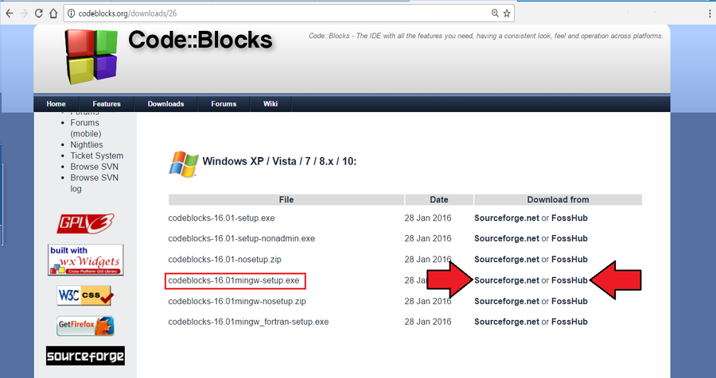

First of all, we must download the code::blocks application from their official websites. For the window version, we should choose mingw-setup.exe file because it includes all of the files deals with code::blocks to make complete installation. Then, choose download link to continue.

### **Step 2**

### Choose the path for the download for this application

When we finished to click to download link, window will appear. Then, it will order you to make a location to place the installer file. So, make a location to save the installer file, and click save button and continue to .download.

# **Step 3**

# **Open the installer**

# 

After the downloading is complete, start to open the installer. The installer will arrive at the location that we specified.

# **Step 4**

# **Run the setup**

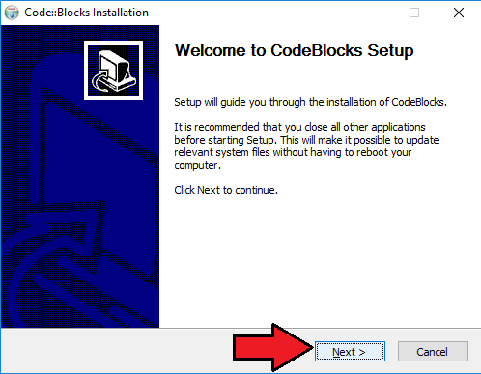

When we finished to open the installer, the setup wizard will occurred on the monitor screen. Then, click “Next” Button to continue the next steps.

# **Step 5**

# **Agree for the official software agreement**

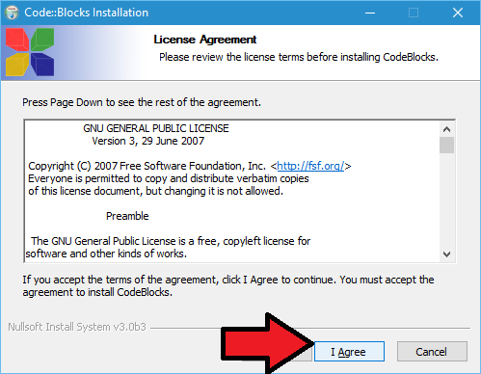

After we clicked the next button from the setup wizard, the window that deals with the agreement of the software license. And, you must read that instructions carefully. If we accept the rules that regarded by the software’s corporation, just click “I Agree” button to continue. Then the installer will allow to install the software.

# **Step 6**

# **Select your constituents as you like**

# 

In this step, we need to select the menu from this window and we must select all constituents from this menu to get the full installation of the software. After we finished to select, click next button to continue next step.

# **Step 7**

# **Indicate the pathof installation**

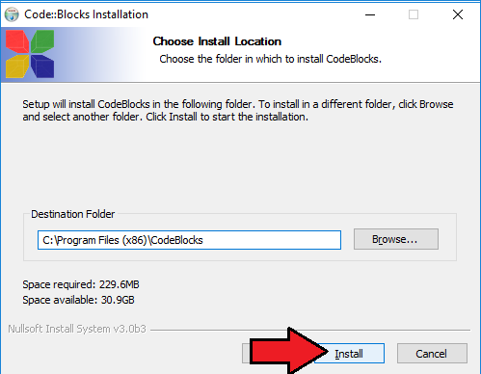

According to the normal way, The software, “Code::Blocks” will install under the window column(c:). When want to install it, we must click install button to install the software (or) if we want to regard the path of install, we need to click the browse button and regard the path and place. Then, click the install button to continue.

# **Step 8**

# **Installation completed!**

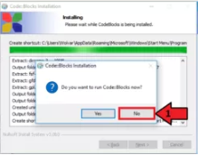 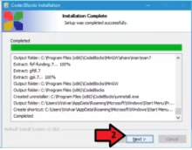 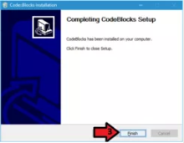

After we had waited to finish for installation, our installation process is almost complete. But, do not run the application first. We must end this process first. So, we need to click the button called “NO” when it asked a question to run this software. Then it will show us the installation had completed. Then, click “Next” button. When it showed the window that the setup had completed, we must click “Finish” Button to start to run the software.

# **Step 9**

# **Initiating and finishing the setup**

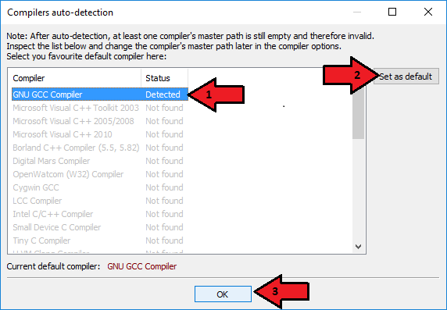

At first, we need to initiate the Code::Blocks software on the desktop. When it was incited, we need to select the “GNU GCC Compiler”. After that, just click “Set as default” button and then click “OK” button to continue.

# **Step 10**

# **Usual file links**

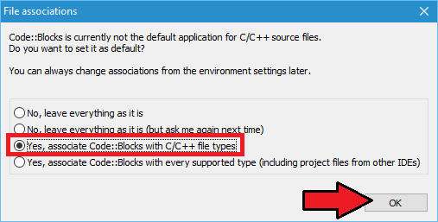

When step 9 was incited, we must select one of the given options called ‘Yes ,associate Code::Blocks with C/C++ file types’ to correlate the C and C++ file types of the Code::Blocks software. And then, click the ‘OK’ Button. This option will help us to open the file types of C and C++ later.

# **Step 11**

# **Start Using the Code::Blocks Software**

These are steps by step by using Code::Blocks Software.

# References

edparrish.net, unknown. *www.edparrish.net.* [Online]   
Available at: http://www.edparrish.net/common/codeblocks.html  
[Accessed 26 February 2019].

overiq.com, unknown. *www.overiq.com.* [Online]   
Available at: https://overiq.com/c-programming-101/installing-code-blocks/  
[Accessed 26 February 2019].

wikihow.com, 2017. *www.wikihow.com.* [Online]   
Available at: https://www.wikihow.com/Download,-Install,-and-Use-Code::Blocks#Questions_and_Answers_sub  
[Accessed 26 February 2019].

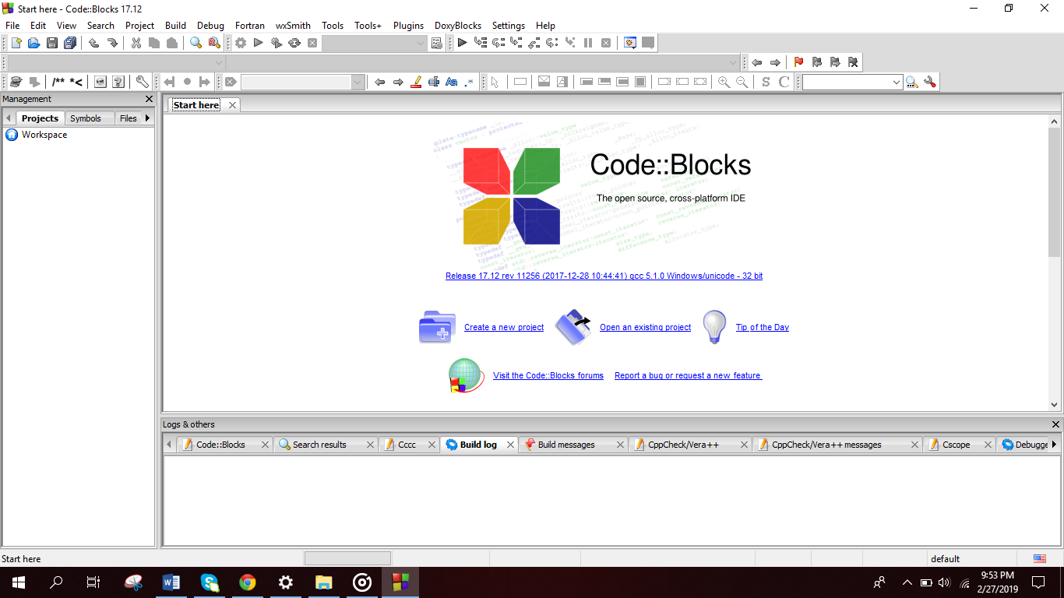 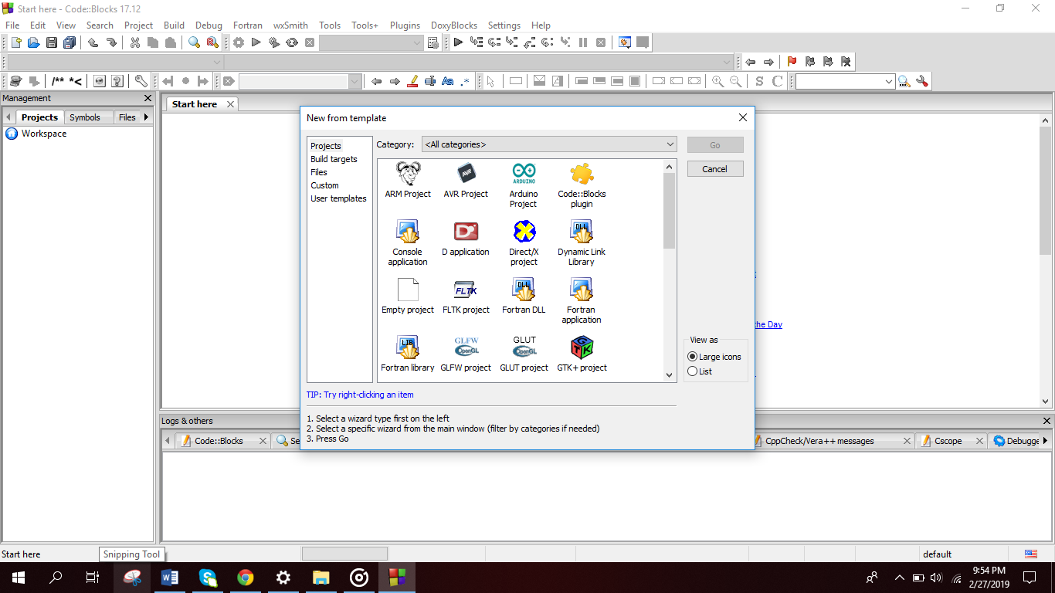

Step 1 Step 2

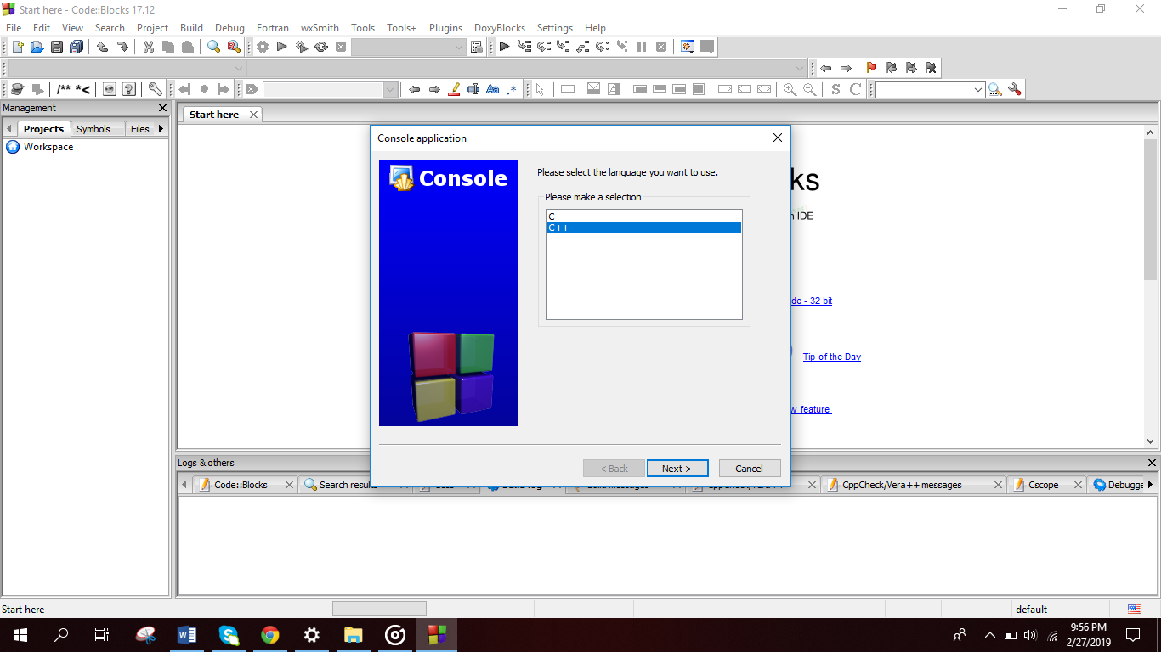 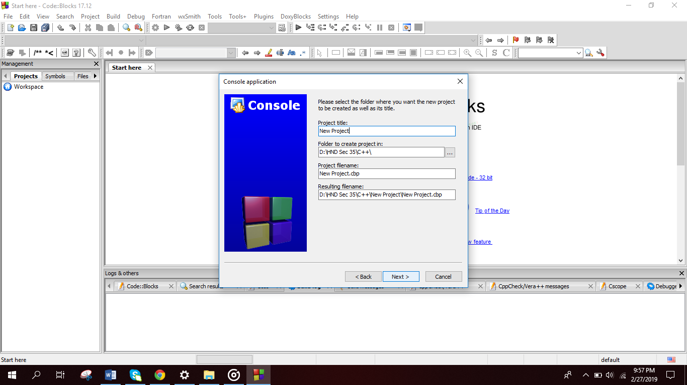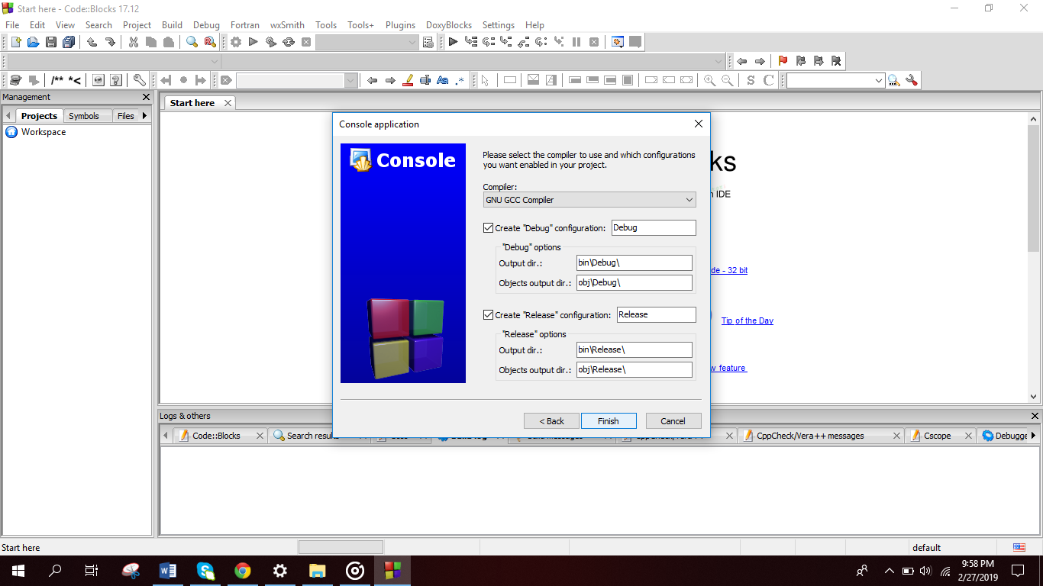

Step 3 Step 4 Step 5

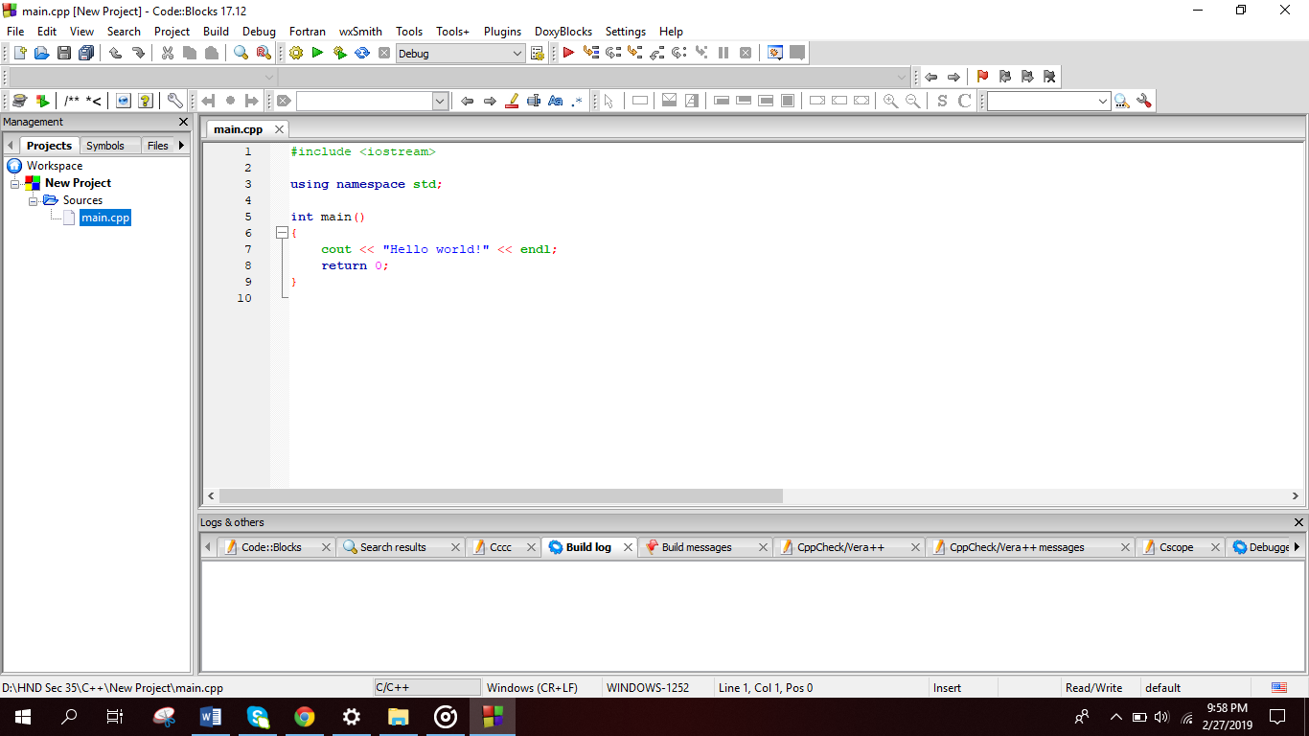 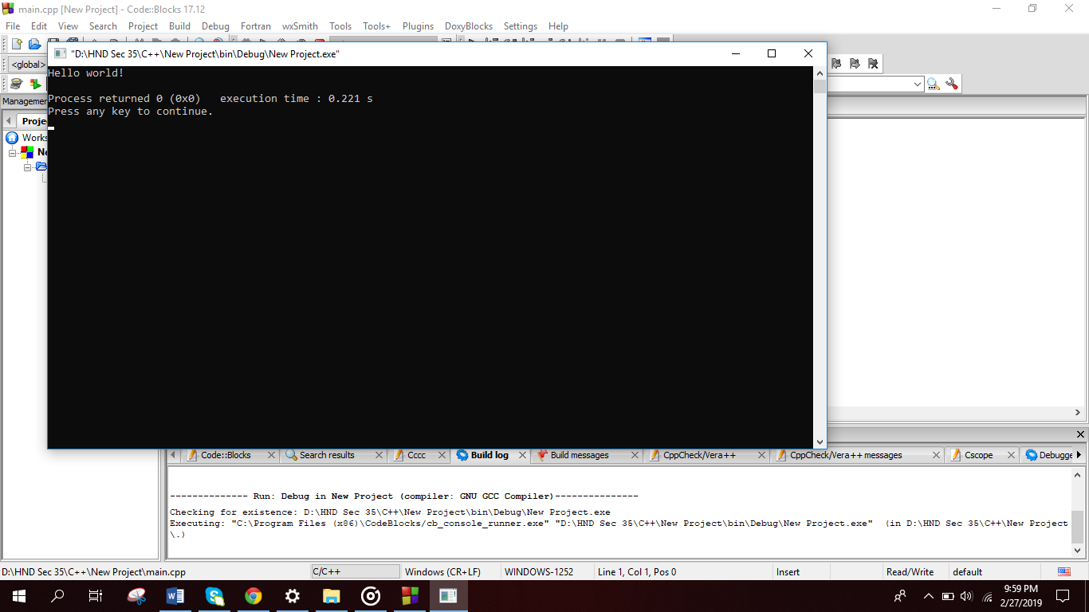

Step 6 Step 7

# References

edparrish.net, unknown. *www.edparrish.net.* [Online]   
Available at: http://www.edparrish.net/common/codeblocks.html  
[Accessed 26 February 2019].

overiq.com, unknown. *www.overiq.com.* [Online]   
Available at: https://overiq.com/c-programming-101/installing-code-blocks/  
[Accessed 26 February 2019].

wikihow.com, 2017. *www.wikihow.com.* [Online]   
Available at: https://www.wikihow.com/Download,-Install,-and-Use-Code::Blocks#Questions_and_Answers_sub  
[Accessed 26 February 2019].

# **Task 3**

# **Antivirus software installation**

# **Step 1**

# **Download the microsoft security essentials**

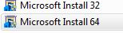

At first, we need to downloaad the official software to safe our pcs security.we must download it from their official website. And we should install mcrosoft 32 bit or 64 bit(we can choose as we like).

# **Step 2**

# **Run the setup**

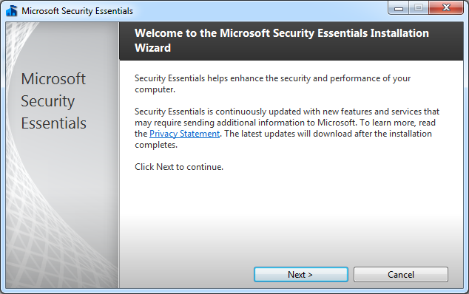

When we finished to download the software, we need to open the setup file to begin an installation of Microsoft security essentials software. When the installer of this freeware is open, click next button to continue.

# **Step 3**

# **Read the license agreement**

When we finished the step 2, we ned to read the license agreement that published by microsoft corporation. If you deal this agreement, click’I accept’ button tocontinue the next steps.

# **Step 4**

# **Joining the customer experience program**

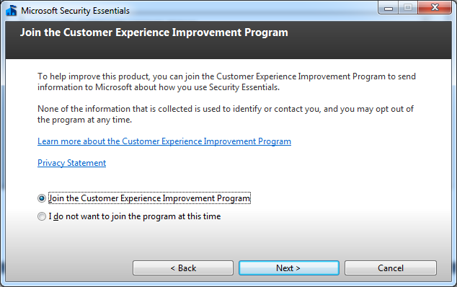

In this window, they will ask to join the customer experience program. If we interest this program, we can click learn more link button. Then, choose the preference and click next button.

# **Step 5**

# **Optimize security for the pc**

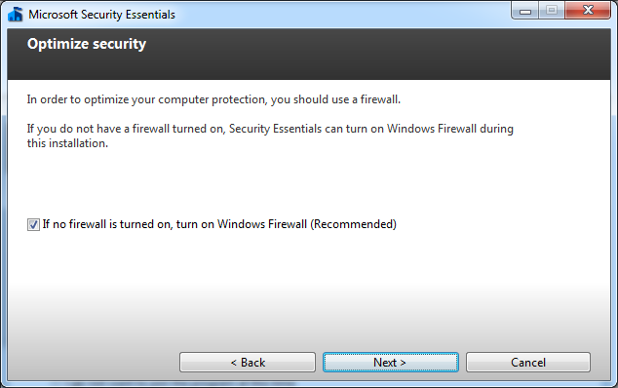

For the security of the pc, we need to choose firewall to turn on for assist the security. Then, click next button to continue.

# **Step 6**

# **Starting the installation of the Microsoft security essential**

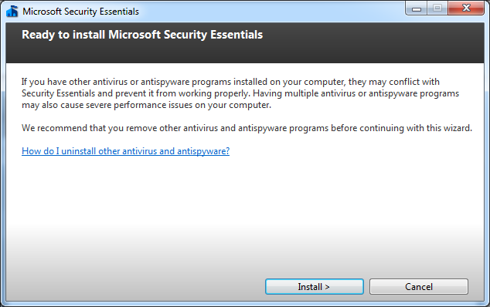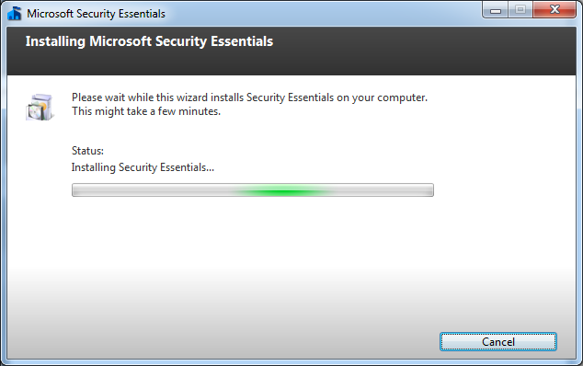

Now, we can start the installation of the Microsoft security essential by clicking the install button.

# **Step 7**

# **Finishing the installation**

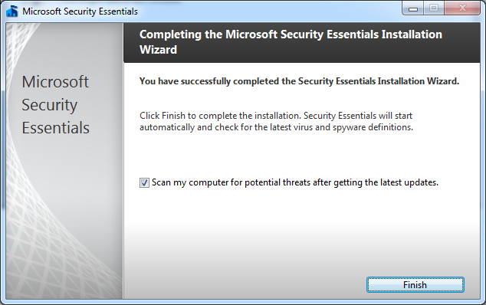

Now, the Microsoft security essentials is completely installed actively and it is also ready to use. Then click finish button to complete your installation processes.

# References

University of Minnesota, 2015. *it.umn.edu.* [Online]   
Available at: https://it.umn.edu/installing-microsoft-security-essentials  
[Accessed 27 February 2019].

wikihow.com, unknown. *www.wikihow.com.* [Online]   
Available at: https://www.wikihow.com/Install-Microsoft-Security-Essentials  
[Accessed 27 February 2019].